Seminar Sheet 1
In Lecture 1 we considered how data and types and variables capture a broad range of diﬀerent information. Data is often separated into characters or digits, complex data units (structs) can be used to logically pair and group data into reusable types. These logical groupings can be be built upon and can represent complex physical and abstract concepts. BSc Games Development is about learning core computer science techniques, and how they can apply directly into developing games mechanics, or systems. One such system is an inventory. Inventories and items are featured across a broad range of genres and games. Depending on the genre, and potentially the audience can change the data required to correctly store or represent the games items. For this seminar sheet I want you to write some C++ code, and create some UML diagrams to demonstrate your thoughts, and ideas. Specify a simple game concept, decide on the game play and decide how the game play will aﬀect the types of data you may need to represent the items and the inventory.

Problem 1.
Design a set of reusable data stores (structs) that can represent the items in your simple game concept from problem 1. Use UML diagrams to illustrate the types of data you want to store and represent. Create 3 example items and show how the structs you have described can represent diﬀerent items.
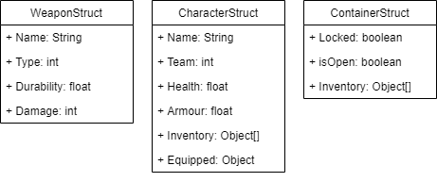

Problem 2.
Implement the UML diagrams you created, in both C++ and Blueprint. Create a blueprint struct to capture and represent the types you have created. Create a C++ struct to mimic the UML structure provided.
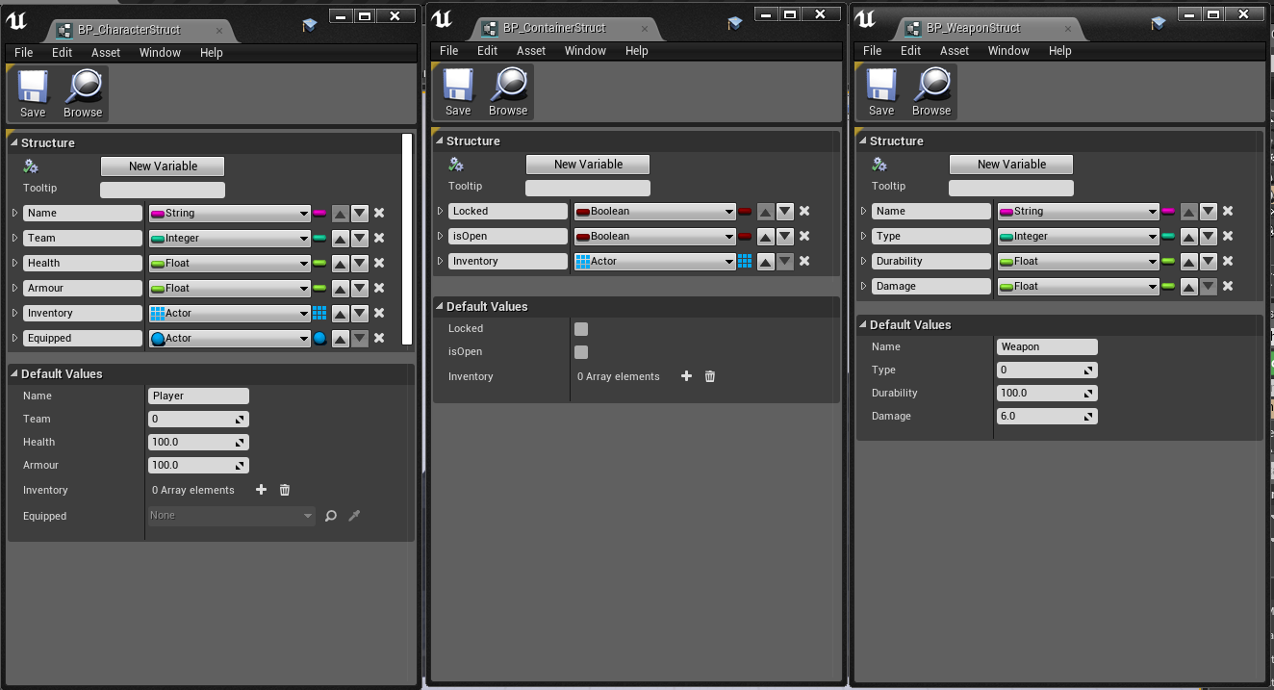
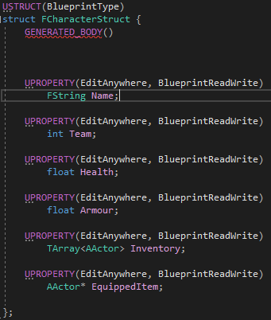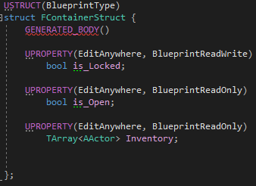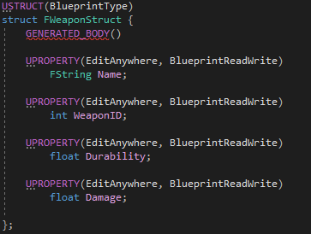

Problem 3 (Extension).
Research how to create a data table object that uses your structs as the core class. Implement a few rows that match the examples you created earlier.
